CS6308 – JAVA PROGRAMMING

LAB EXPERIMENT – 1 &

PRACTICE QUESTIONS

.

NAME: HEMANTH N

REG NO: 2019503519

1. Write a program that takes as input fahrenheit temperature. It converts the Input temperature to celsius and prints out the converted temperature as shown In the example. The formula for conversion between the two is: c=5/9(f−32), Where c is the temperature in celsius and f is the temperature in fahrenheit. Round your answer to up to two de cimal places.

**CODE:**

import java.util.Scanner;

public class hems_lab_1 {

public static void main(String[] args) {

Scanner in = new Scanner(System.in);

System.out.println("By HEMANTH N | 2019503519");

System.out.println("Enter input in Fahrenheit\n");

double c,f;

f = in.nextDouble();

c = (f-32)*(0.5556);

System.out.printf("The temperature equivalent of "+f+" in Celsius is %.2f",c);

}

}

**OUTPUT:**

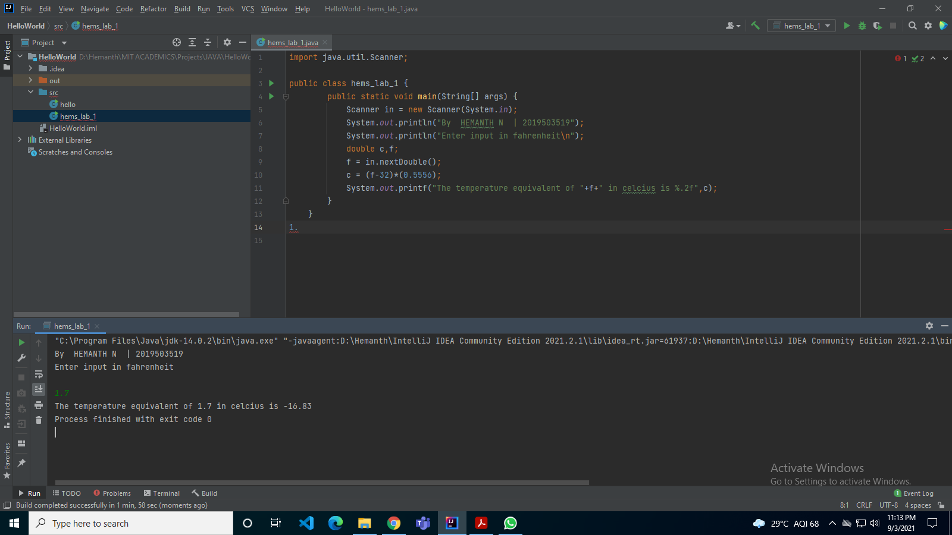

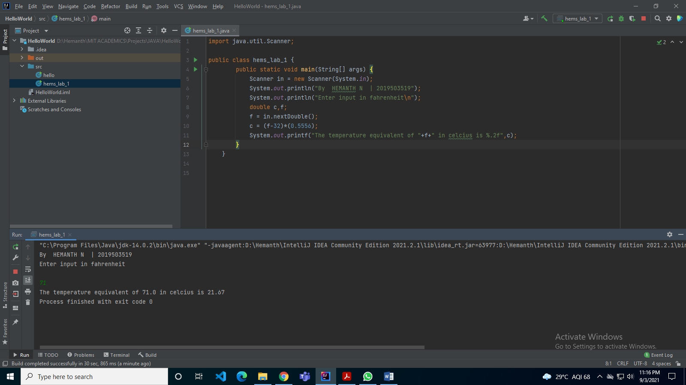

1. Write a program that takes as input three numbers, u, a, and t. Here u stands forthe initial velocity, a stands for the acceleration, and t stands for the time duration. The program prints the final velocity (v). V=u+at recall that u and a can take any real (float) values as velocity and acceleration are continuous vector quantities (in physics). Time t can take non-negative real values only, i.e., 0 ≤ .note: round your answer to up to two decimal places.

**CODE:**

import java.util.*;

public class hems_lab_1_2 {

public static void main(String[] args) {

Scanner in = new Scanner(System.in);

System.out.println("BY HEMANTH N 2019503519");

double u,a,t,v;

System.out.println("Enter initial velocity - ");

u = in.nextDouble();

System.out.println("Enter acceleration - ");

a = in.nextDouble();

System.out.println("Enter time duration - ");

t = in.nextDouble();

v = u + a*t;

System.out.printf("The final velocity is %.2f",v);

}

}

**OUTPUT:**

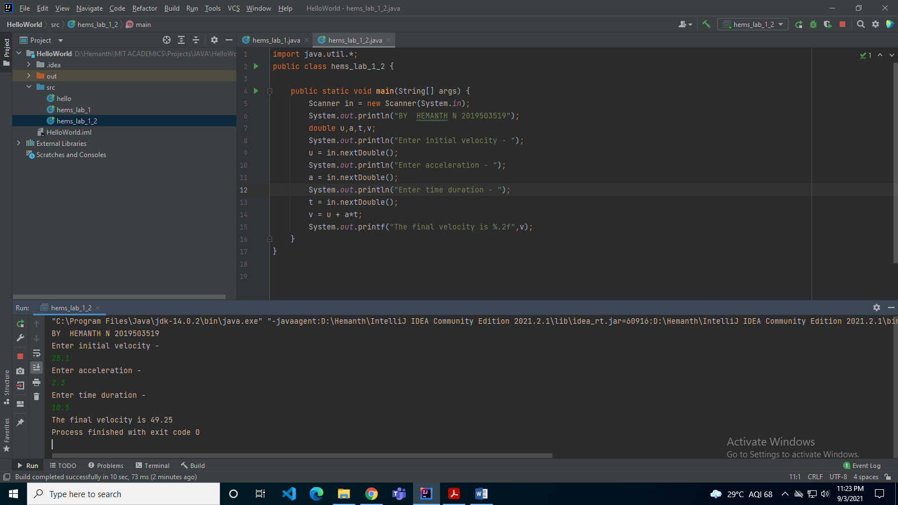

1. Write a program that takes as input three numbers, u, a, and t. Here u stands for the initial velocity, a stands for the acceleration, and t stands for the time duration. The program prints the displacement covered (d) in time t. Recall that u and a can take an y real value as velocity and accele ration are continuous vectors (in physics). Time t can take non-negative real values only, i.e., 0 ≤ t.note: round your answer to up to two de cimal places.

**CODE:**

import java.util.*;

public class hems_lab_1_3 {

public static void main(String[] args)

{

Scanner in = new Scanner(System.in);

System.out.println("BY HEMANTH N | 2019503519");

double u,a,t,d;

System.out.println("Enter initial velocity - ");

u = in.nextDouble();

System.out.println("Enter acceleration - ");

a = in.nextDouble();

System.out.println("Enter time duration - ");

t = in.nextDouble();

d = u*t + 0.5*a*t*t;

System.out.printf("The displacement is %.2f",d);

}

}

**OUTPUT:**

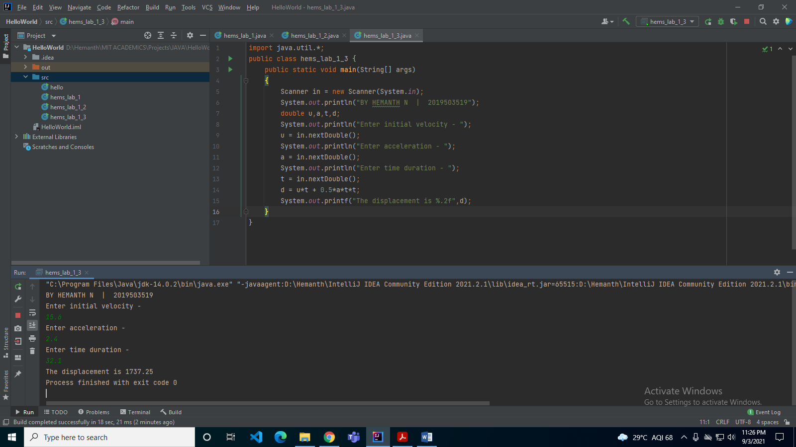

1. Write a program that takes as input an integer s, the number of seconds elapsed for a certain event. The program converts s to hours (hh), minutes (mm), and seconds (ss) and prints the output as hh:mm:ss.

**CODE:**

import java.util.*;

public class hems_lab_1_4 {

public static void main(String[] args) {

Scanner in = new Scanner(System.in);

System.out.println("By HEMANTH N 2019503519");

int s,hh,mm,ss;

System.out.println("Enter number of seconds elapsed - ");

s = in.nextInt();

ss = s % 60;

hh = s / 60;

mm = hh % 60;

hh = hh / 60;

System.out.printf("Output: %d:%d:%d",hh,mm,ss);

}

}

**OUTPUT:**

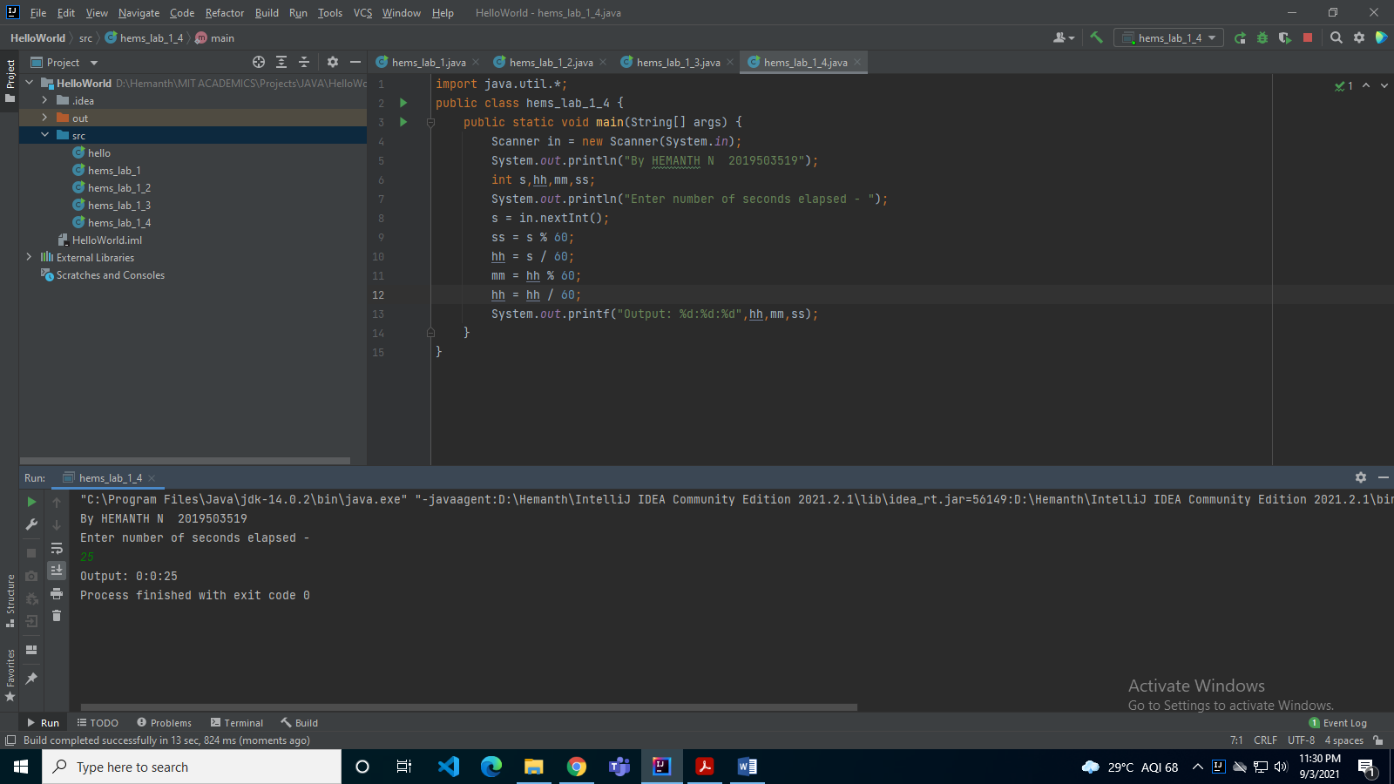

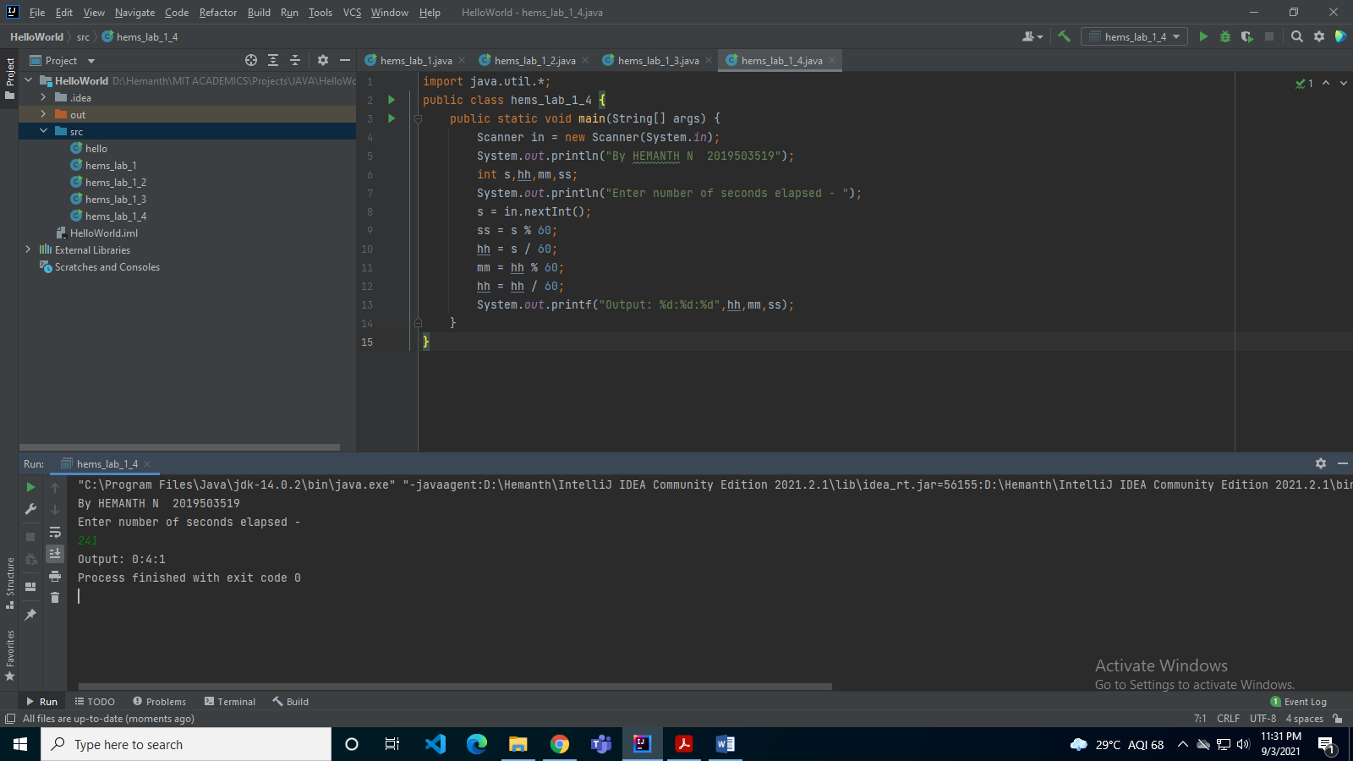

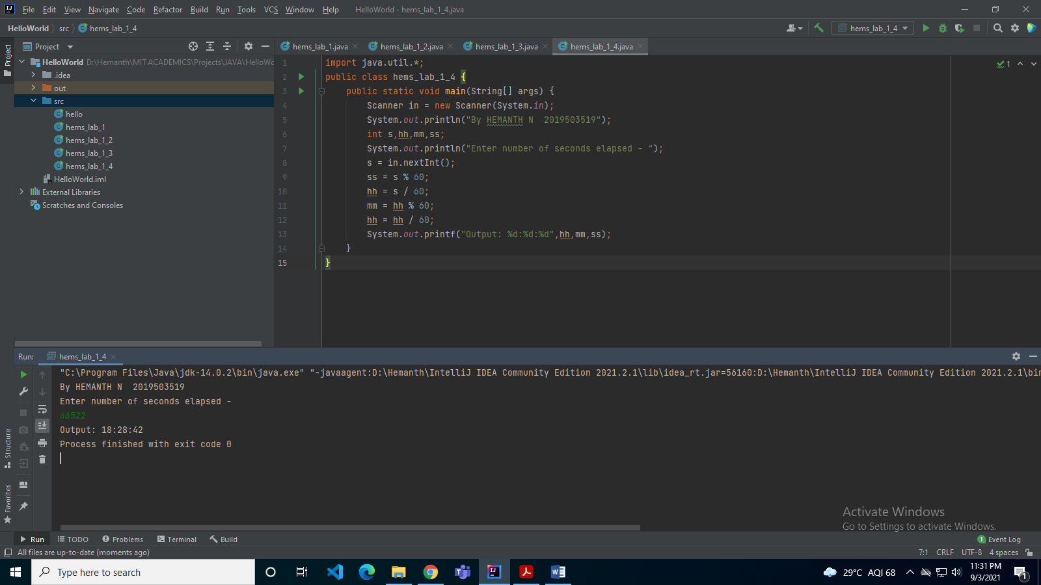

**PRACTICE PROBLEMS**

1. Finding the Hypotenuse of a triangle

**CODE:**

import java.util.*;

public class practice

{

public static void main(String[] args) {

Scanner in = new Scanner(System.in);

System.out.println("Enter the two values");

System.out.printf("Enter the value a :");

double a = in.nextDouble();

System.out.printf("Enter the value b :");

double b = in.nextDouble();

double c = Math.sqrt(a*a + b*b);

System.out.println("hypotenuse is "+c);

}

}

**OUTPUT:**

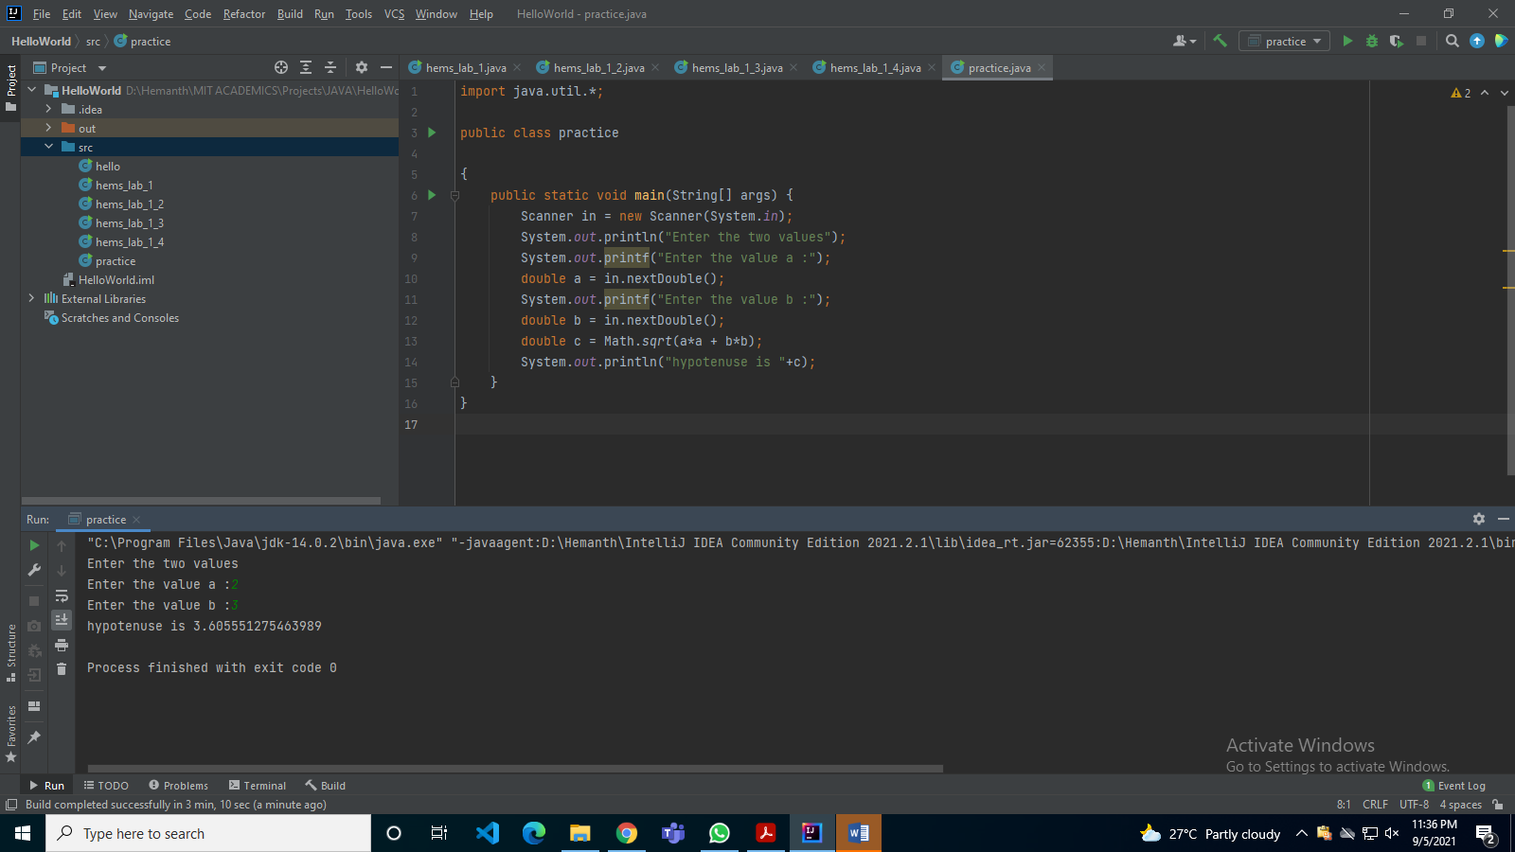

1. Block of a scope

**CODE:**

import java.util.*;

public class practice

{

public static void main(String[] args) {

Scanner in = new Scanner(System.in);

int x;

x = 24;

if(x == 24)

{

int y = 16;

System.out.printf("\nx and y inside If statement is x=%d and y=%d",x,y);

x = y * 2;

}

int y = 100;

System.out.printf("\nx and y outside If statement x=%d and y=%d",x,y);

}

}

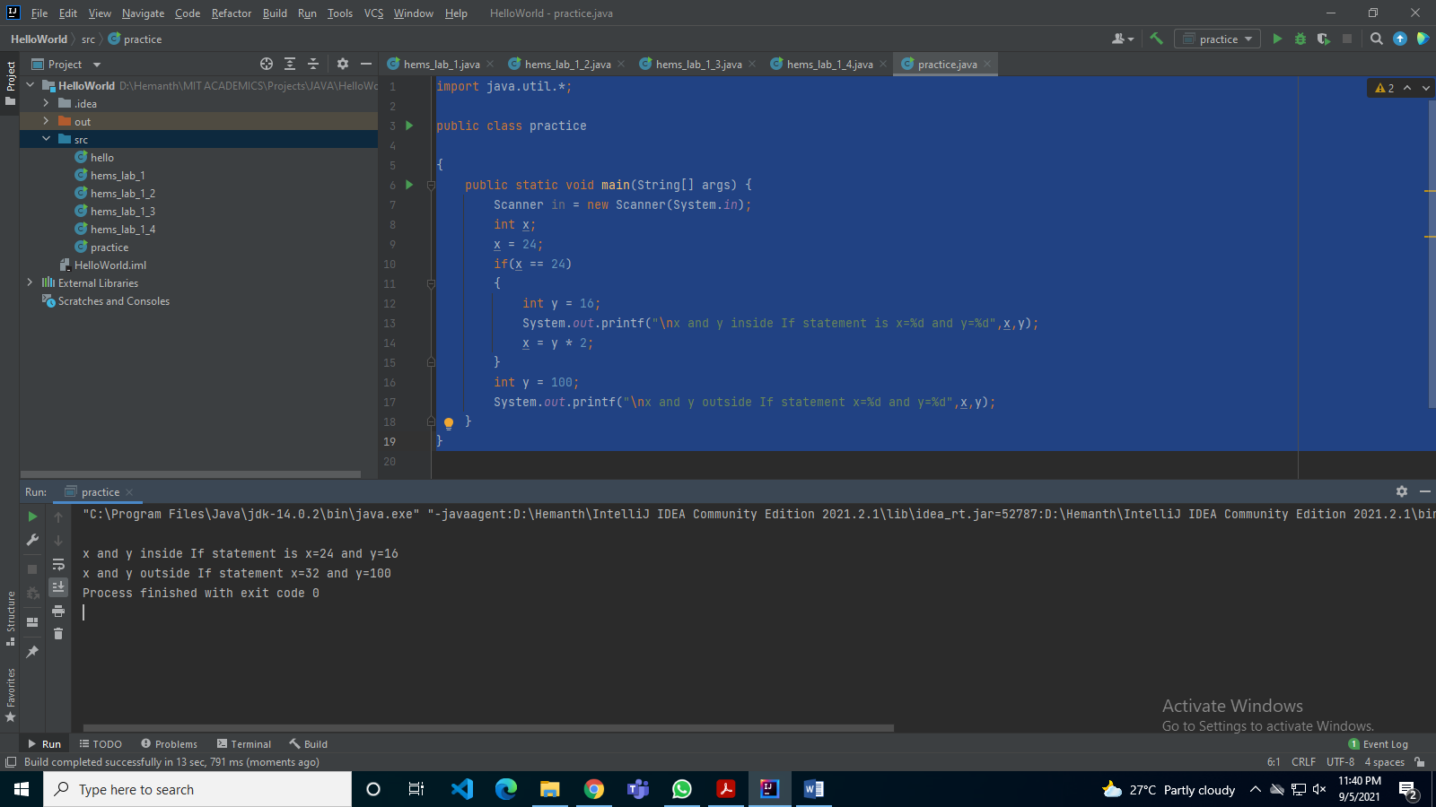

1. Format the output example

**CODE:**

import java.util.*;

public class practice

{

public static void main(String x[])

{

Scanner sc = new Scanner(System.in);

float n = sc.nextFloat();

int n1 = (int)n;

float s = n - n1;

int ans = (int)(s*100);

System.out.println("First Two decimal places of "+n1+" is "+ans);

}

}

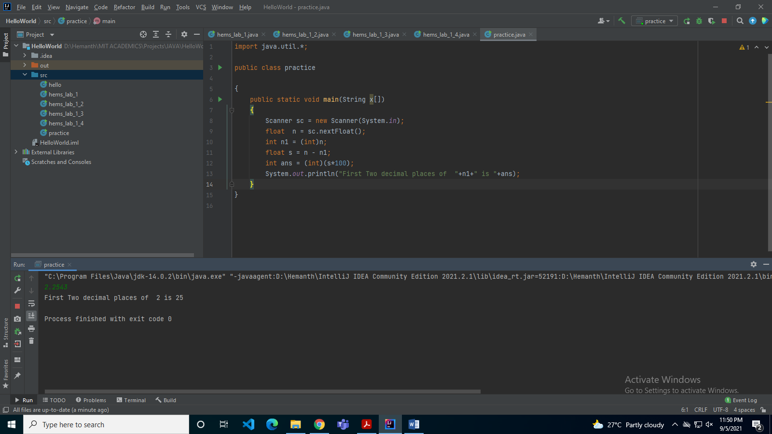

1. Printing the no of days in a month – Array

**CODE:**

import java.util.*;

public class practice

{

public static void main(String[] args)

{

Scanner in = new Scanner(System.in);

int days[]= {31,28,31,30,31,30,31,31,30,31,30,31};

String months[] =

{"January","February","March","April","May","June","July","August","September","October","November","December"};

System.out.println("Months and days");

for(int i=0;i<12;i++)

{

System.out.println(months[i]+" has "+days[i]+" days");

}

}

}

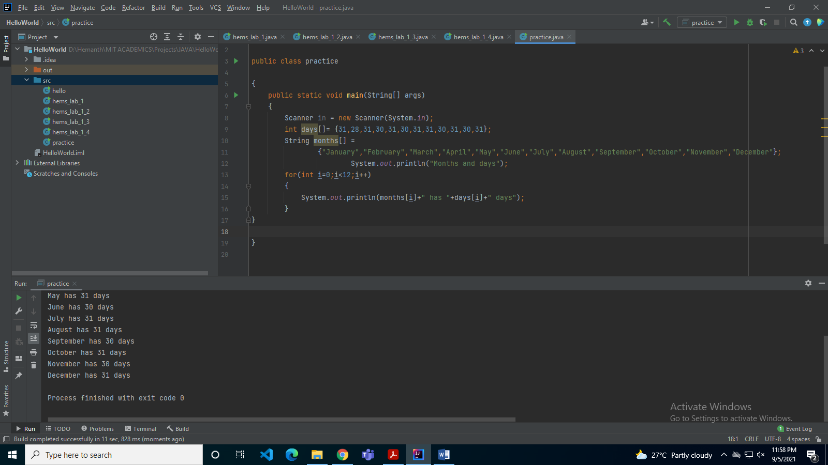

1. Print a 2Dmatrix in n*m and m*n forms

**CODE:**

import java.util.*;

public class practice

{

public static void main(String x[])

{

Scanner sc = new Scanner(System.in);

int a[][]= new int[2][3];

for(int i=0;i<2;i++)

for(int j=0;j<3;j++)

a[i][j]= sc.nextInt();

for(int i=0;i<2;i++)

{

for(int j=0;j<3;j++)

System.out.print(a[i][j]+" ");

System.out.println();

}

System.out.println('\n');

for(int i=0;i<3;i++)

{

for(int j=0;j<2;j++)

System.out.print(a[j][i]+" ");

System.out.println();

}

}

}

